21 November:
Feast of the Presentation of the Blessed Virgin Mary
Assembly

Play this Gathering music to be played as the students are settling:
(No need to play the entire song - see what is appropriate for the group)

Welcome and Introduction:
Student Lead

Reader | SLIDE | SCRIPT
 | 1  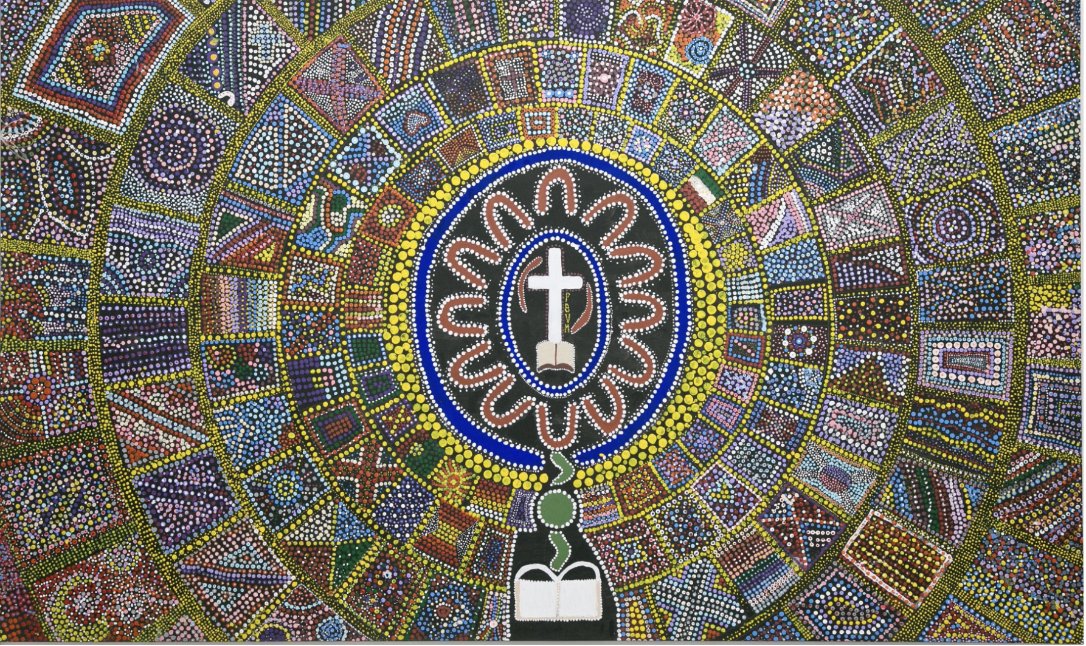 | Good morning staff and students.  Today we begin our assembly with an acknowledgement of country:  We acknowledge and pay respect to the traditional owners of the land on which we meet, the Wangal people of the Eora nation.  It is upon their ancestral land that Domremy College is built.  As we share our own knowledge, hopes and dreams within this school may we also pay respect to the knowledge embedded forever within the Aboriginal Custodianship of Country.  PAUSE________________________________________________________________________  This image featured in the slide is one that we are all familiar with, however, not all of us are aware of the rich symbolism that is expressed - today we would like to unpack just a few elements for you.  The painting itself contains many significant elements which symbolise the values and history of Domremy College.  The cross in the centre of the artwork, symbolises a point of communication between heaven and earth. From there the dark green represents the College’s circular driveway and heritage gates that welcome visitors to the College community. Within the circle, there is an oval shape, which is representative of the silver ring worn by the Presentation Sisters. With the letters ‘PBVM’ standing for ‘Presentation of the Blessed Virgin Mary’ in the centre, on the right hand side of the cross, appearing vertically, the painting serves to connect the Domremy community with Aboriginal culture by designing these letters into the shape of a traditional Aboriginal shield.  The 12 U shapes around the oval represent the original 12 students of the College when it was founded in 1911 by the Presentation Sisters that devoted their lives to ensuring children could be educated in the Catholic faith. Over the years there have been more than one hundred Presentation Sisters who have worked at Domremy College, so it is fitting that we remember the service that they gave to establish this wonderful community.  Let’s learn about what the colours represent. At the same time please take this opportunity to reflect on how you, as a Domremy student are fulfilling your part of the contract that was signed when you enrolled here at the College:  - Navy blue - makes reference to the original navy blue uniform, as well as the qualities of truth, intellect, wisdom, loyalty and peace, which the College promotes in the life of students.  - Am I a student demonstrating these qualities as I walk through the corridors, sit in the classrooms, and hang out in the playground?  - Gold - symbolises divine power, enlightenment and God’s light.  - Am I reflecting God’s light in my encounters with others at the College and beyond the College gates?  - Red - represents love, joy, faith, power and dignity.  - In my dealings with staff and students do I view the world through a lens of love and treat others with dignity which is central to Christ’s message?  - Yellow dots - radiating from the centre, represent Nano Nagle’s lantern as it continues to shine true for the College community. Nano is a great example of a woman who lived by the motto deeds not words.  - Are you a young woman of right action?
  PAUSE - 30 seconds
  PAUSE - 30 seconds
  PAUSE - 30 seconds
  PAUSE - 30 seconds
 | 2  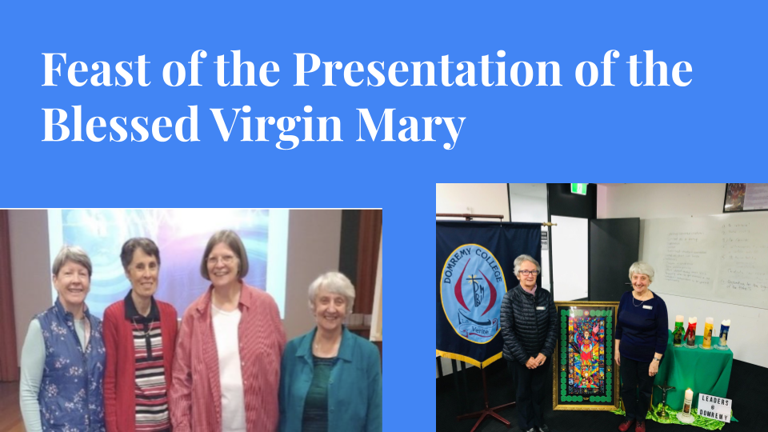 | We gather in a spirit of reflection and prayer, connecting with our past, present and future as Presentation People. We accept the challenge of carrying the light of Nano Nagle and passing on this light to generations to come.  This week Presentation People around the world connect as one community as we prayerfully and joyfully celebrate Mary of the Presentation. All over the globe people have been praying the Presentation Novena which we began here at Domremy on Friday 12 November in the Chapel.  Nano Nagle drew strength and inspiration from Mary of the Presentation, whose feast day was on Sunday 21 November. Usually on this special occasion of commemorating the Feast Day of the Presentation of the Blessed Virgin Mary we would welcome our very special guests, the Presentation Sisters. However, due to Covid restrictions we are unable to celebrate this significant feast with them. We sincerely thank them in their absence for being the constant support they are to Domremy. We acknowledge this today and value their contributions, which are on so many levels. We look forward to next year when they shall be able to join us here at the College.
 | 3  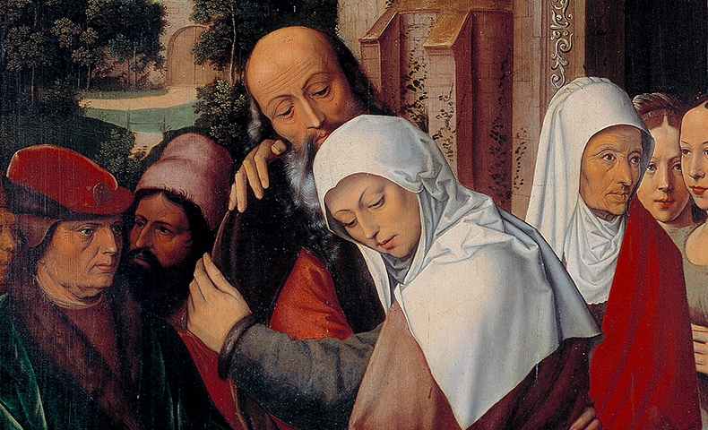 | As we reflect on the meaning of this Feast day we recall Mary’s parents - St Anne and St Joachim.  In thanksgiving for the God's gift of Mary's birth, they brought her to the Temple to consecrate their only daughter to The Lord. We recognise and celebrate Mary’s ‘Yes’ to God and her dedication.
 | 4  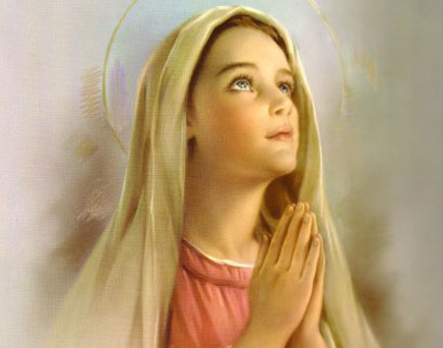 | It is an early tradition of both the Eastern and Western Church that Mary, as a small child, was presented to God by her parents in the Temple in Jerusalem.
 | 5  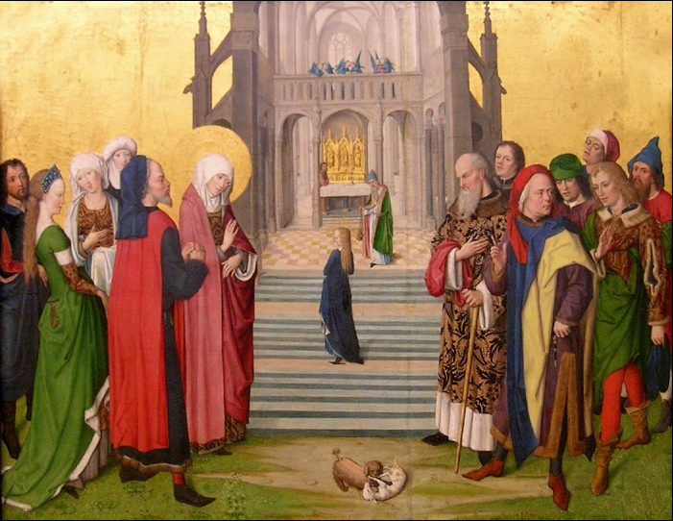 | Presentation people are called to be ‘Temple-people’. Like Mary, presented in the Temple, we too are called to be people of contemplation – filled with the Holy Spirit that leads us to be in solidarity with those who are oppressed.
 | 6  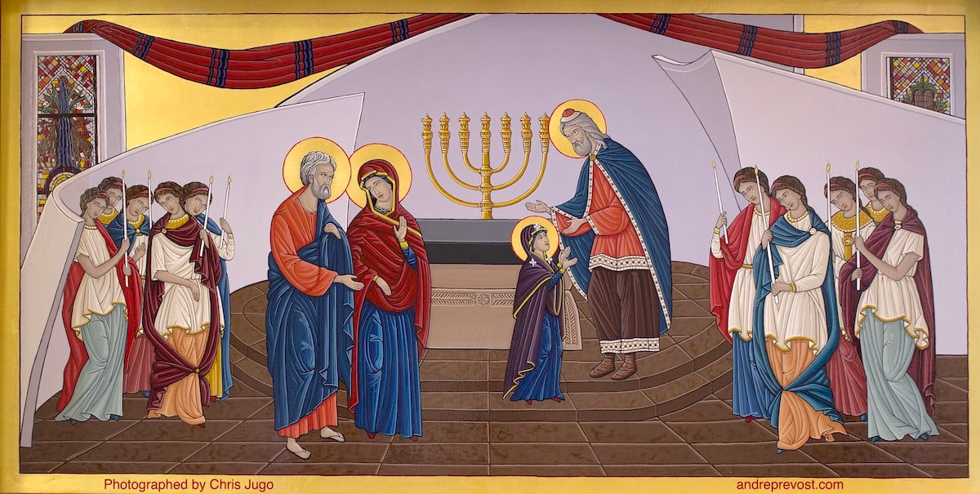 | Mary - A Jewish peasant woman in partnership with God: She gifted the world with Jesus. How else might you imagine Mary?  PAUSE
 | 7  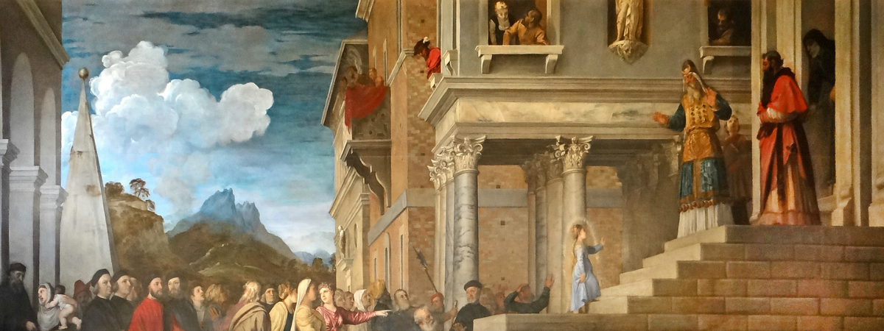 | We acknowledge that the customs of the ancient world are different to the ways of our modern society when we reflect on this Feast Day.
 | 8  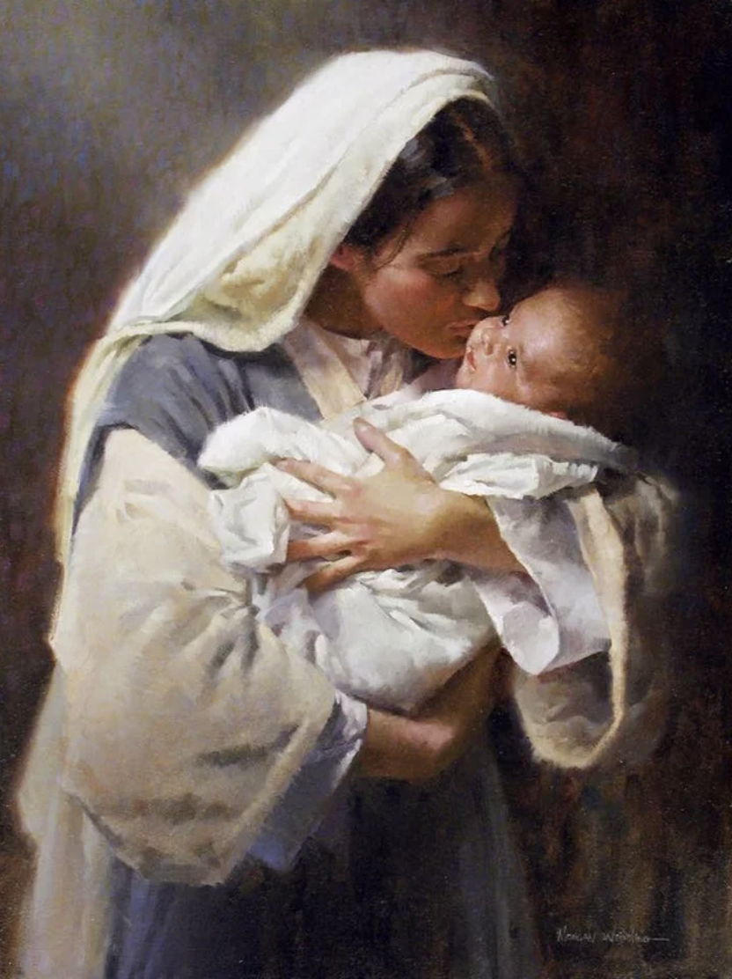 | This custom did prepare Mary well for the role she played as the Mother of Jesus. Mary of Nazareth, Woman of Unconditional Yes.
 | 9  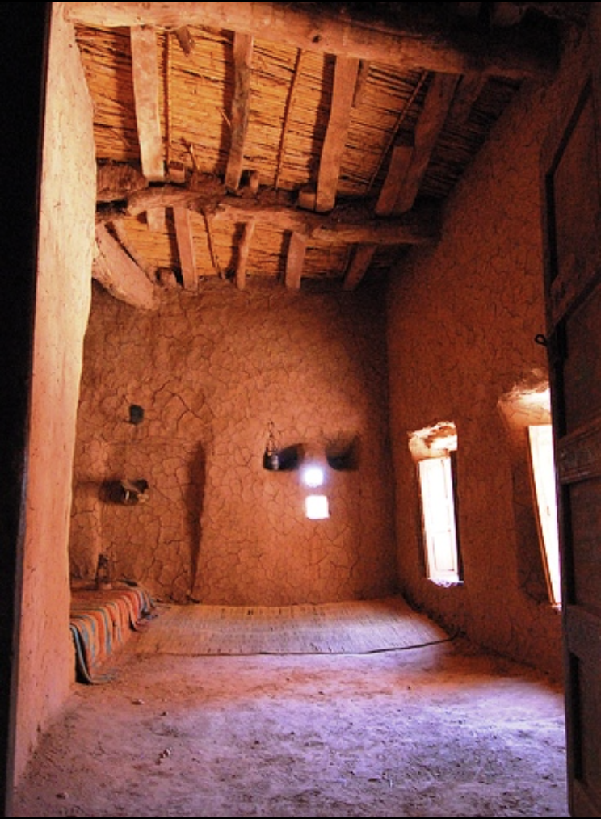 | Mary - lead a simple life - in fact the majority of people lived their life with great simplicity. This image shows the type of home that Mary and her parents lived in. Basic. No trimmings. No lavish furnishings. Let us take a minute to ponder all those who live their life with just the basic necessities. How can we strip away things from our life that cause clutter and distraction from what is really important.
 | 10  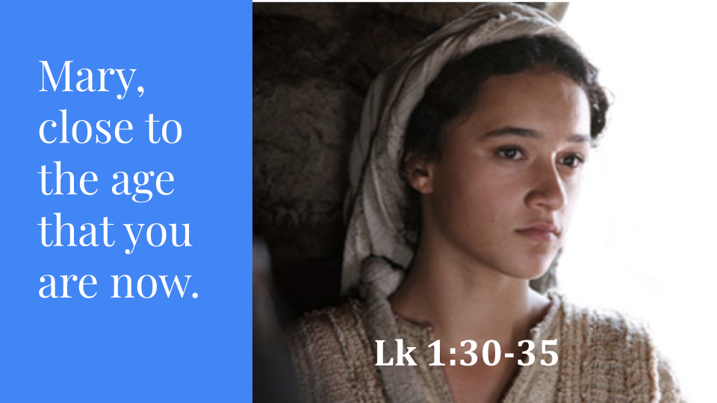 | Let us begin our prayer now with the ‘Sign of the Cross’ - when your house colour is indicated, please read what is on the screen together.  In the name of the Father, and of the Son, and of the Holy Spirit, Amen.  We are Called to Ponder  Then the angel said to her, “Do not be afraid, Mary .... Behold, you will conceive in your womb and bear a son, and you shall name him Jesus .... But Mary said to the angel, “How can this be, since I have no relations with a man?” And the angel said to her in reply, “The Holy Spirit will come upon you ...”  Mary is afraid – “deeply troubled” – yet continues to say yes to the Spirit. Reflect now on what it means for you to be a ‘woman of unconditional yes’. PAUSE  Are there implications to this ‘yes’? PAUSE  We acknowledge that:
 | 11. | (Notre Dame House)  God Planted the seed of life in the womb of Mary with her YES at the Annunciation,
 | 12 | (Nagle House)  God planted the seed in the heart of Nano with her YES in responding to the needs of the poor in her native Ireland,
 | 13 | (Orleans House)  And God called the young women as Presentation Sisters to establish Domremy College in the Five Dock area, in the early 20th Century,
 | 14 | (Martina House)  We are called today to celebrate the Feast of the Presentation of the Blessed Virgin Mary, gathered together as a community joined in spirit.
 | 15 | We call to mind these women who have played a significant role in our faith tradition.  You are called today to ….  Silence….  Deep Listening….  Heartfelt Response…  Awareness…..  Hospitality and Welcome….  Courage…  Trust…..  Communion….  Journeying together as Presentation People…..  May God’s blessing be among us as we respond to these calls.  Mary of the Presentation,  ALL:Pray for us.  Venerable Nano Nagle,  ALL: Pray for us  In the name of the Father, and of the Son, and of the Holy Spirit, Amen.
 | 16  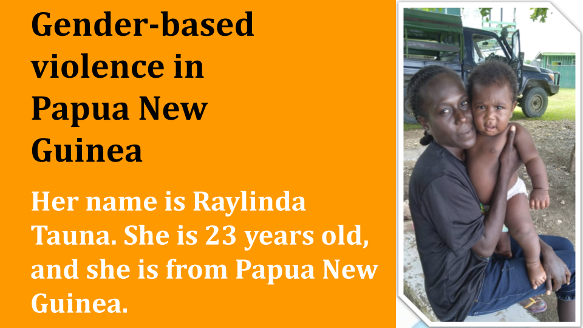 | During October Mrs Sullivan received an email that shared a very sad, true story which expressed the challenging reality of Gender-Based Violence, that continues to occur daily in Papua New Guinea; where a number of Presentation Sisters are active in ministry. The email asked for Domremy, as a Presentation People School to HELP. Mrs Sullivan said YES on our behalf. When you hear the story you will understand why she could not say NO.  Please listen with an open heart to Raylinda and her young infant’s plight. You will be moved by the struggles she is facing on multiple levels, and understand the need for her to be safe and care for her young child. We too are also moved by the love, compassion and tenacity of our Sisters working at the grassroots in Papua New Guinea.
 | 17  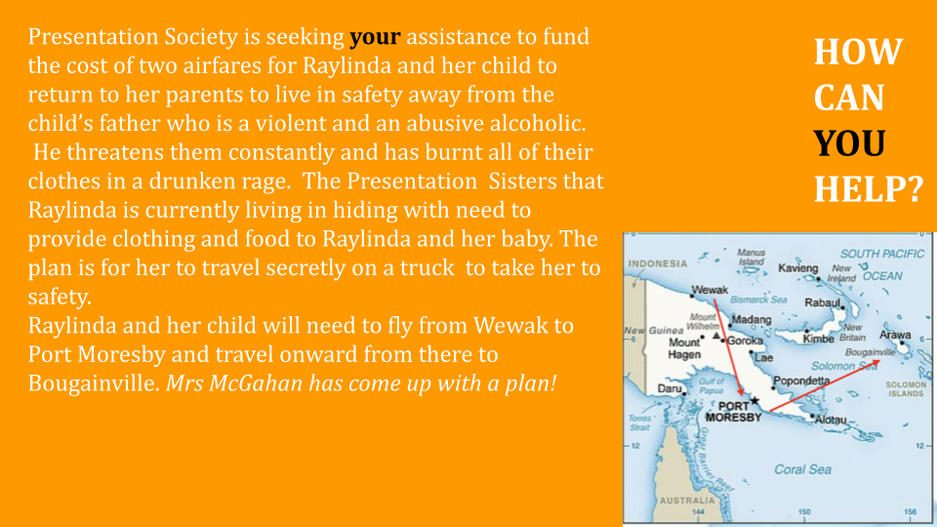 | Presentation Society is seeking your assistance to fund the cost of two airfares for Raylinda and her child to return to her parents to live in safety away from the child’s father who is a violent and an abusive alcoholic.  He threatens them constantly and has burnt all of their clothes in a drunken rage. The Presentation Sisters that Raylinda is currently living with in hiding need to provide clothing and food to Raylinda and her baby. The plan is for her to travel secretly on a truck to the airport to take her to safety.  Raylinda and her child will need to fly from Wewak to Port Moresby and travel onward from there to Bougainville. This all costs money.  Mrs Sullivan has a plan how we can raise the funds.
 | 18   | This Friday, please wear MUFTI - AND BRING A GOLD COIN to donate which will assist with getting Raylinda and her child to safety - away from violence. The Presentation Association United Nations Advocacy Focus for the next few years is “Eliminating Violence against Women and Children” and tomorrow it is the International Day for the Elimination of Violence against Women. Please have a coin ready on Friday in homeroom as we do not have option to give out any change! You will receive and orange ribbon to where as a symbol of solidarity for this cause.
 | 19   | Firstly, as you choose what you are planning to wear, take a moment to thank God that you have choice. Raylinda and her child left their home with only the clothes on their back. So give your gold coin with a grateful heart and be aware of how much you have in your life to be thankful for. Secondly, choose sensibly and know what is appropriate for a Domremy student to wear to school for a mufti day. That means cover your midriff, which is the abdomen area and wear closed in shoes. Thank you Domremy girls - we know you will support this venture, just like you gave generously for the Hampers which are being picked up tomorrow for Nagle Centre.

